Software Requirement Specification Document

For

Credit and Debit card fraud detection system

Table of Contents
Page Numbers
- Introduction 3
  - Purpose 3
  - Intended Customers/Users 3
  - Product Scope 3
  - Outline of the document3

- Overall Description3-5
  - Product Perspective3
  - Product Functions 3-4
  - User Classes4
  - Design and Implementation Constraints 4-5
- Diagrams
  - UML Diagrams 5-14
    - Use case diagrams 5-7
    - Class diagrams 7-10
    - State diagrams and activity diagrams 10-15
    - Sequence and collaboration diagrams 16-19
  - ER Diagrams 19-20
  - DFD Diagrams 20-21
  - Assumptions and Dependencies
- External Interface Requirements/Screenshots 21-22
  - User Interfaces 21
  - Hardware Interfaces 22
  - Software Interfaces 22
  - Communication Interfaces 22
- Other Non-Functional Requirements 22-23
  - Performance Requirements 22
  - Safety Requirements 22-23
  - Security Requirements 23
  - Software Quality Attributes 23
  - Business Policies/Rules (if any) 23
- Testing 23-33
  - Block-Box Testing23-28
  - White-Box Testing 28-33
- Conclusion 34

- INTRODUCTION
1.1 Purpose
- Why this software is being developed: This system is being built to protect online and offline banking transactions.
- What problem it solves: It solves the problem of financial theft where criminals use stolen card details to make purchases. It stops these transactions before money is lost.
- What this SRS document contains: This document lists the features, user roles, external connections, and limitations of the project.
1.2 Intended Customers and Users
- Bank Customers: The people who own the credit or debit cards.
- Bank Administrators: Staff members who manage the banking software.
- Fraud Analysts: Specialized staff who investigate suspicioustransactions.
- Merchants: Shop owners or online stores that accept card payments for their users.
1.3 Product Scope
- The software monitors transactions as they happen.
- It checks for suspicious activity, like a sudden large purchase or a purchase in a different country.
- It alerts the bank and the customer immediately if fraud is detected.
- It can automatically block a card to prevent further loss.
1.4 Outline of the Document
- Chapter 1.1: Explains why we are doing this project and who it is for.
- Chapter 1.2: Describes the environment where the software will run and its main functions.
- Chapter 1.3: Lists the rules and limits we must follow while building the system.

2. OVERALL DESCRIPTION
2.1 Product Perspective
- System Type: This is not a standalone system, it is part of the larger core banking system.
- It interacts with the Bank Database to check account balances and history.
- It connects to Payment Gateways to read incoming transaction data.
- It uses SMS/Email Servers to send alerts to customers.
2.2 Product Functions
- Monitor Data: Continuously reads transaction details like Time, Amount, Location.
- Detect Fraud: Uses rules and history to spot weird patterns.
- Send Alerts: Notifies the customer via SMS if a transaction looks risky.
- Block Transactions: Automatically declines payments that have a very high risk score.
- Generate Reports: Creates summaries for bank staff about how many frauds were stopped.

2.3 User Classes
Administrator class :
- Has full control over the system settings.
- Can add or remove fraud analysts.
- Maintains the rules for detection.
Fraud Analyst class :
- Views the list of suspicious transactions.
- Contacts customers to verify purchases.
- Updates the status of a case to check if its is fraud or original.
Customer class :
- Does not log into this system directly.
- Receives notifications and OTPs.
2.4 DESIGN AND IMPLEMENTATION CONSTRAINTS
2.4.1 Hardware Limits
- The servers need very high RAM and fast processors to handle millions of transactions at once.
- A large amount of hard drive space is needed to store logs of past transactions.
2.4.2 Software Requirements
- The system must run on a secure Operating System like Linux.
- It requires a fast database like SQL to look up user history quickly.
2.4.3 Regulatory Rules
- The system must follow banking laws and data protection acts.
- Customer data must be private and cannot be shared with unauthorized people.
2.4.4 Network Dependency
- The system requires a 24/7 high-speed internet connection.
- If the network is down, real-time fraud detection cannot work.
2.4.5 Database Size
- Transaction history grows very fast, so the database must be expandable.
- It must handle older data storing without slowing down new transactions.
2.4.6 Browser-Specific Issues
- The dashboard for the analysts should work on all major web browsers like Chrome, Edge, Firefox, Brave.
2.4.7 Security Constraints
- All data stored must be encrypted.
- Staff members accessing the system must use two-step verification password an OTP.

3.DIAGRAMS
3.1 UML Diagrams
Use Case Diagrams
Module 1: User & Security Management
- Customer: Represents the bank client who logs into the application to access their personal account services.
- Admin: A privileged user who manages the system, assigning roles to other users and overseeing security settings.
- Database: An external system that securely stores user credentials (like passwords) and encrypted profile data.

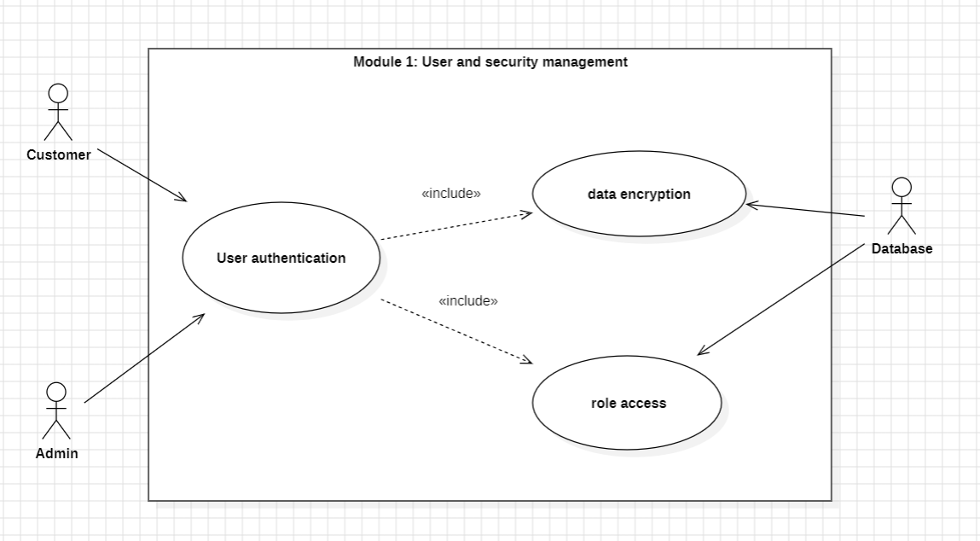

Module 2: Transaction Processing
- Merchant: The entity (shop or website) that initiates a transaction request when a customer tries to buy something.
- PaymentGateway: An external service that the system communicates with to authorize the actual transfer of funds.
- Database: Acts as a digital ledger that saves the details of every transaction (date, amount, location) for record-keeping.
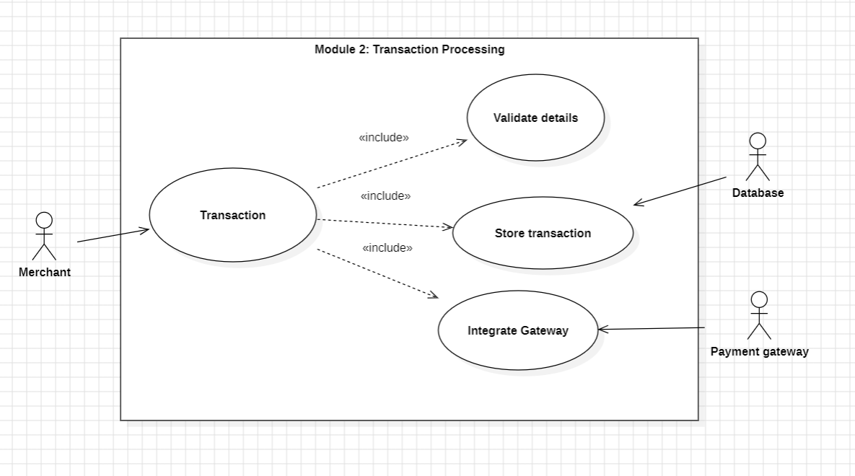
Module 3: Fraud Detection & Analysis
- SystemTrigger: An automated timer or event that instantly starts the analysis process whenever a new transaction is captured.
- MLEngine: The "brain" of the operation, an external system that uses artificial intelligence to calculate a risk score for the transaction.
- HistoricalDB: A database actor that provides past transaction history so the system can check if the current transaction matches the user's usual behaviour.
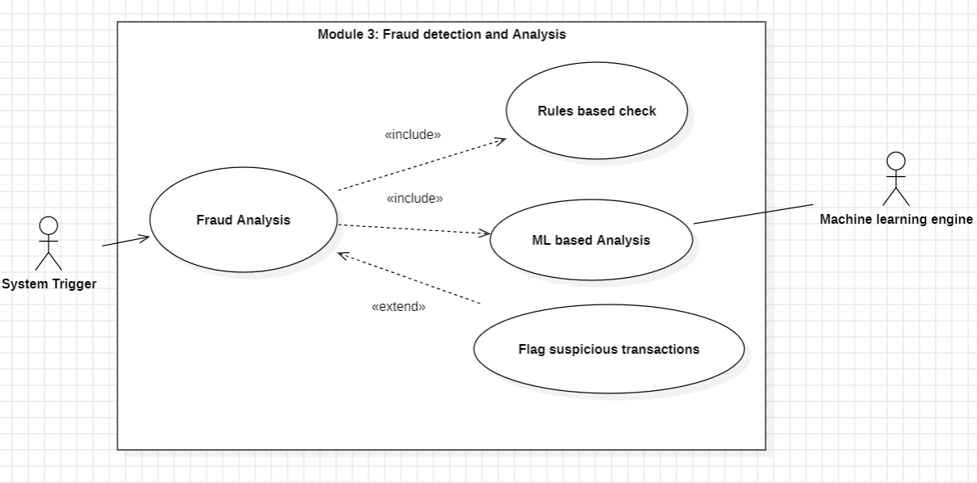
Module 4: Alert, Control & Reporting
- System: The internal controller that executes the final decision, such as automatically blocking a high-risk transaction or approving a safe one.
- Customer: The recipient of automated SMS or email alerts if the system detects suspicious activity on their card.
- Admin: Receives comprehensive fraud reports and analytics to help them understand fraud trends and update system rules.

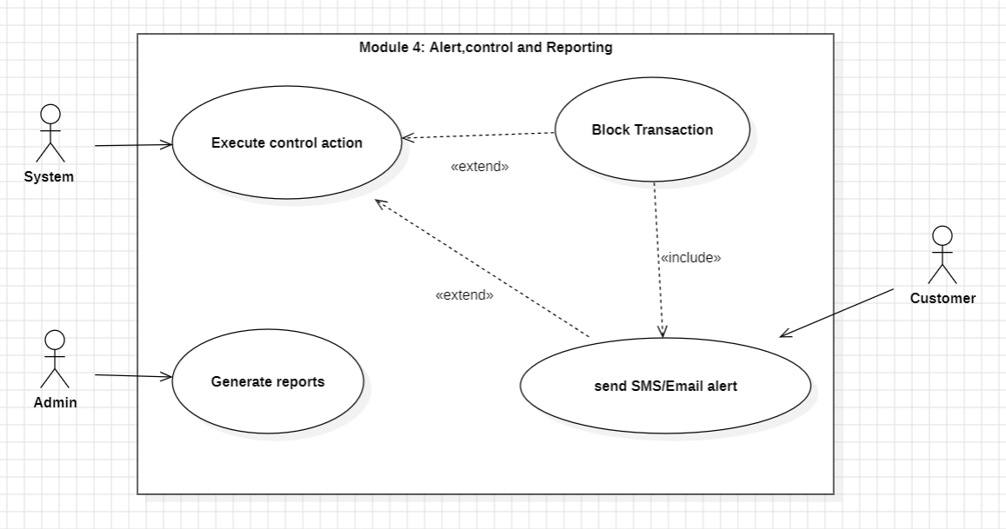

Class Diagrams
Module 1: User & Security Management
- User Hierarchy: We have a main User class that holds basic info like ID and name. The Customer and Admin classes inherit from it, meaning they get all those basic features plus their own special ones.
- Strong Ownership of Credentials: The filled diamond shows a "composition" relationship. This means a User completely owns their Credentials (password data); if you delete the user, their credentials get deleted too.
- Encapsulation: Notice the little minus signs (-) before attributes like password hashes. This means that data is private and hidden inside the Credentials class for security, and can only be checked using the public +verify() method.

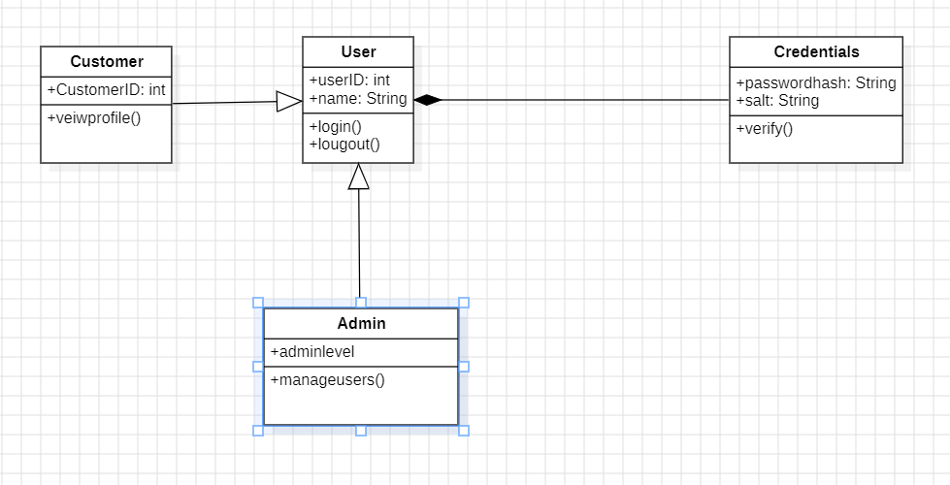

Module 2: Transaction Processing
- Connecting the Dots: The central Transaction class links everything together. It knows which Card was used, which Merchant it was at, and has all the details like amount and time.
- Real-World Rules (Multiplicity): The numbers on the lines tell a story. For example, one Card can have many (0..*) Transactions, but each transaction belongs to exactly one Card.
- Talking to Outsiders: The IPaymentGateway box is a special interface. It's like a contract that says, "Any payment system we connect to (like Visa or PayPal) must have an authorize() method for us to call."
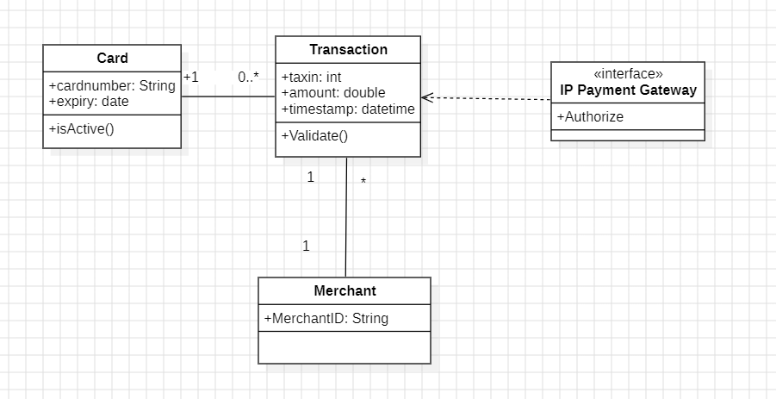
Module 3: Fraud Detection & Analysis
- Separation of Concerns: The main FraudAnalyzer class acts as a coordinator. It doesn't do the heavy lifting itself, it delegates the work to specialized classes like RuleEngine and MLModelProxy.
- Checking the Past: The RuleEngine has a connection to CustomerProfile. This allows it to look up the user's history to see if the current transaction looks suspicious compared to their usual habits.
- Standardized Results: Both the simple rules and the complex ML model return their findings as a standard RiskScore object, making it easy for the system to understand and compare the results.

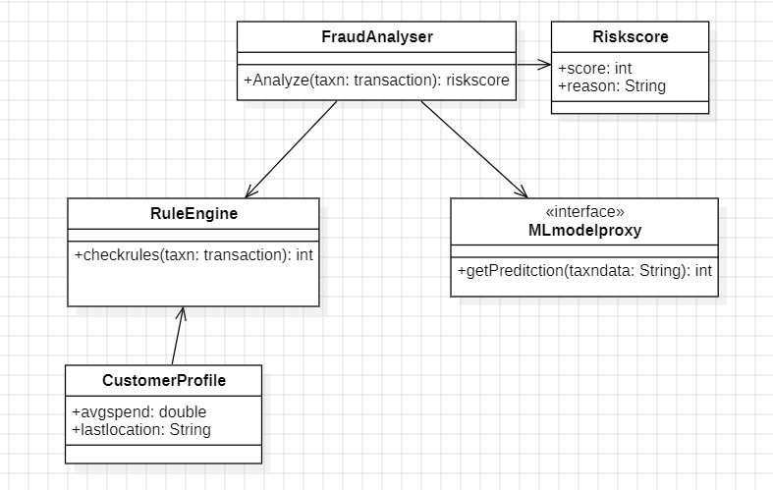

Module 4: Alert, Control & Reporting
- Taking Action: The ActionController is the boss here. Based on the risk score, it decides whether to create a BlockAction to stop the transaction or an ApproveAction to let it through.
- Flexible Notifications: The NotificationService is designed to be flexible. It can send alerts through different channels, represented by the SMSAlert and EmailAlert classes that inherit from a base Alert class.
- Building Reports: The ReportGenerator class is responsible for gathering data from past actions and transactions to create summary reports for administrators.

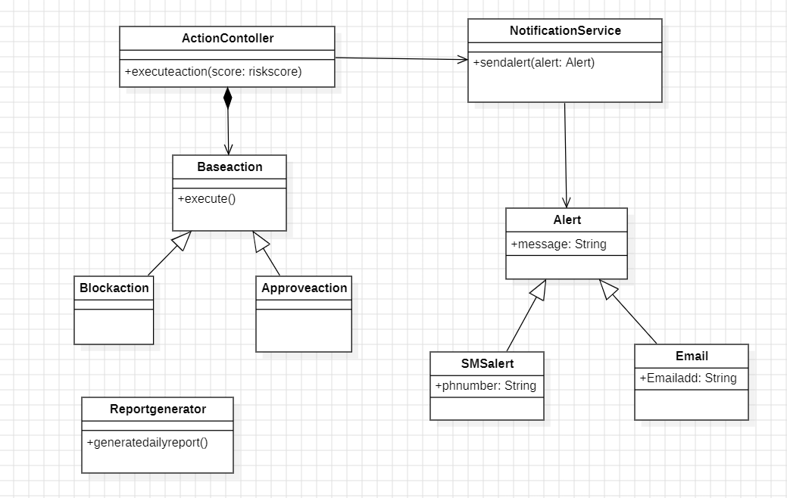

State Diagram 1: Transaction Object Lifecycle
- The Journey of a Transaction: This diagram shows every stage a transaction goes through, from the moment it's created ("Initiated") to when it's finally stored away ("Archived").
- The Decision Point: The key part is the "Analyzing" state. Based on the risk score from Module 3, the transaction's path splits into three possible outcomes: "Approved," "Blocked," or "FlaggedForReview."
- Final Destination: No matter what happens during analysis, every transaction eventually ends up in the "Archived" state for record-keeping.
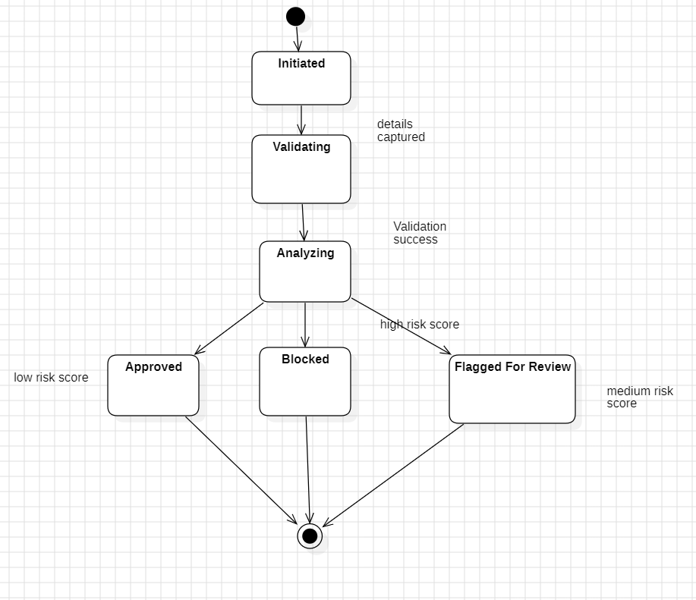

State Diagram 2: User Account Lifecycle
- Managing User Status: This diagram tracks the status of a user's account in Module 1. It starts as "New" and becomes "Active" after verification.
- Handling Problems: It shows the negative states an account can fall into: "Locked" (e.g., after too many wrong passwords) or "Suspended" (if fraud is suspected).
- A Way Back: Crucially, it shows that these negative states aren't permanent. An admin can unlock a locked account, and a cleared investigation can restore a suspended account to "Active."

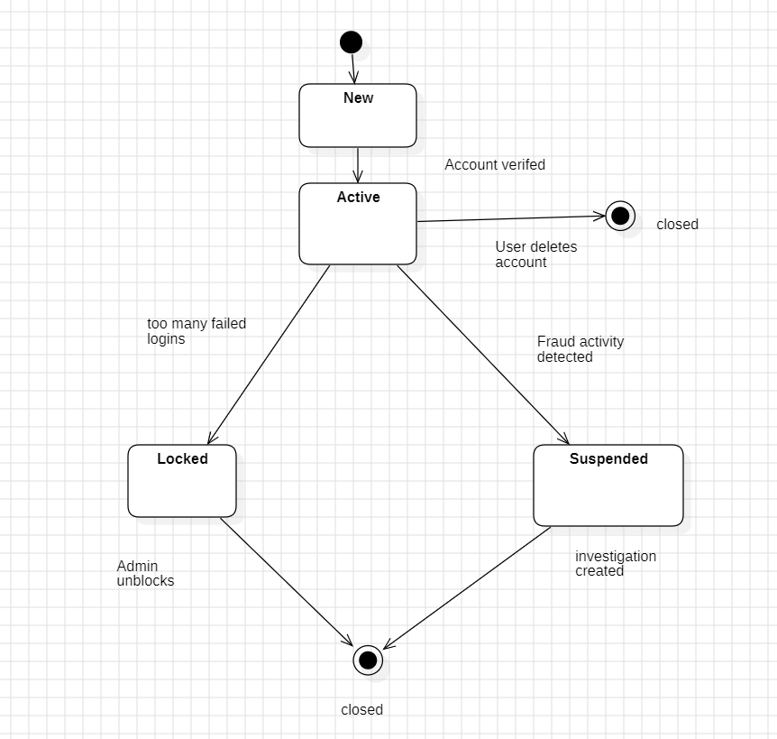

Activity Diagram 1: End-to-End System Workflow
- The Big Picture: This diagram shows the entire life of a transaction, from the merchant swiping the card to the final approval or rejection. It connects all your modules together.
- Parallel Processing: The thick black bars are "fork" and "join" nodes. They show that the system runs the "Rule-Based Checks" and "ML-Based Analysis" at the same time to be faster.
- Final Action: The workflow ends with a decision based on the final risk score, leading to one of three actions: blocking the transaction (and sending an alert), approving it, or rejecting it early if basic validation fails.

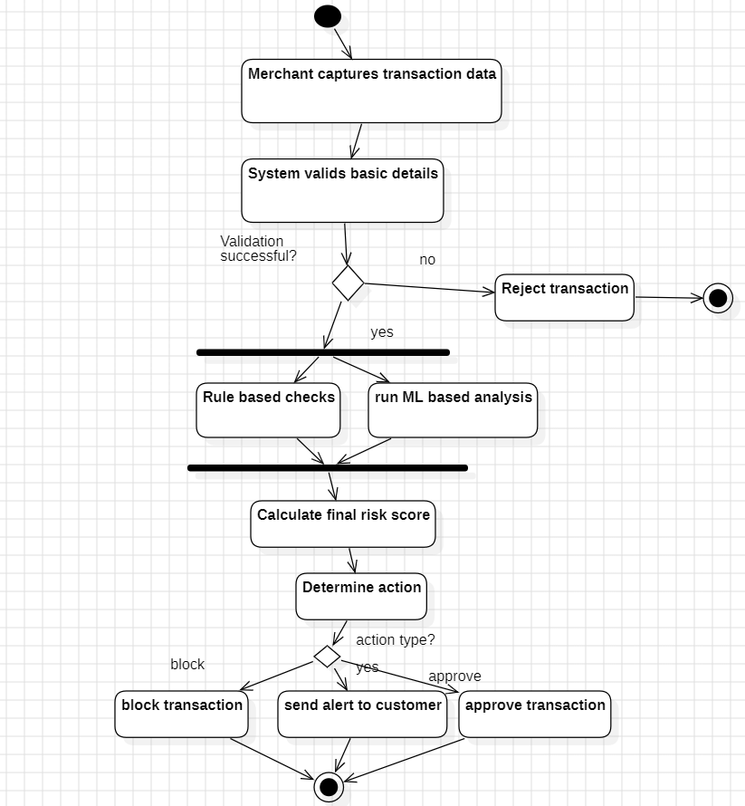

Activity Diagram 2: Detailed Fraud Analysis Process (Mod 3)
- Zooming In on the Brain: This diagram is a detailed look inside the "Analyzing" step from the first diagram. It shows exactly how Module 3 works.
- Step-by-Step Logic: It shows the sequence: get the customer's history, run a specific rule check (like location), make a decision based on that rule, get the ML model's prediction, and finally combine everything into one score.
- Decision Points: The diamond shape shows a clear "if/else" decision—if a rule is triggered, a high score is assigned; otherwise, a low score is assigned.

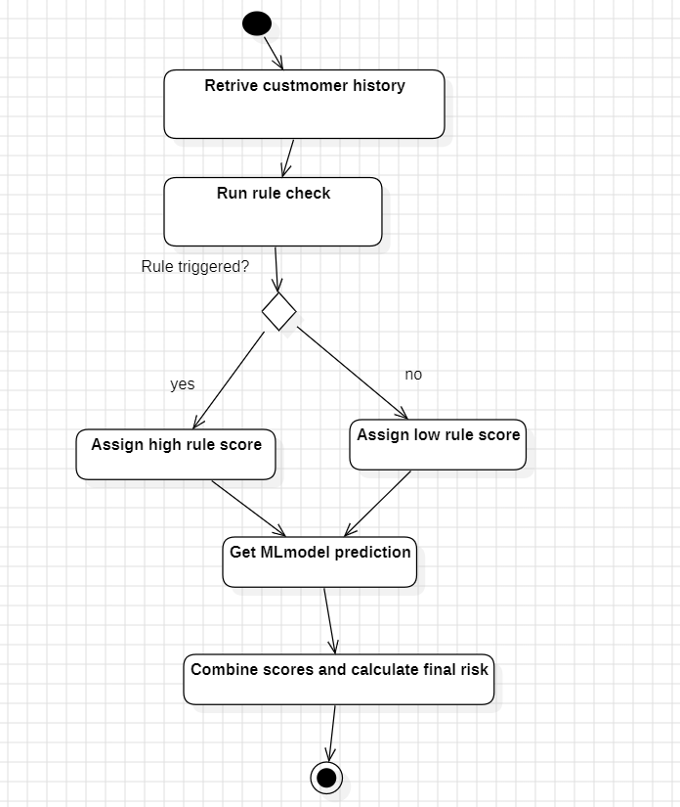

Sequence Diagrams
1. User Login Scenario
The Trigger: The process begins when the Customer (Actor) enters their User ID and Password to the system, sending a login() message.
Secure Verification: The User object doesn't check the password itself; it passes the sensitive work to the Credentials object using the verify() command.
The Result: The Credentials object checks the password hash and returns a simple true or false back to the User object, which then tells the Customer if they are logged in or not.

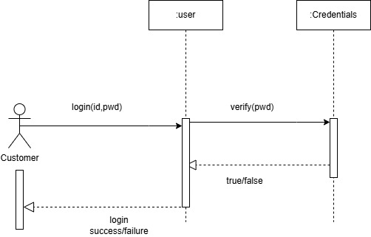

2. Process Transaction Scenario
Initiating the Sale: The Merchant starts the flow by sending purchase details (like amount and date), which creates a generic Transaction object.
Pre-Check: Before talking to the bank, the Transaction object asks the Card object, "Are you active?" (isActive()) to ensure the card isn't locked or expired.
External Authorization: If the card is okay, the system contacts the IPaymentGateway (the external bank system) to authorize() the amount and waits for an approval code.
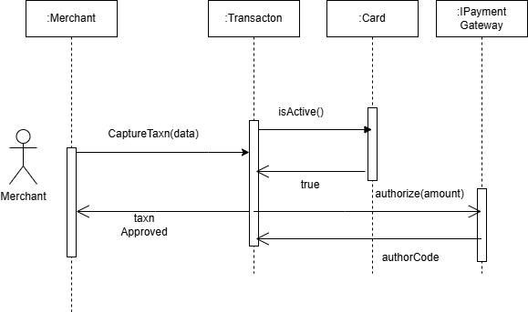

3. Analyze Fraud Scenario
The Manager: The FraudAnalyzer acts as the central coordinator. When the system triggers it to analyze(), it takes charge of the whole process.
Gathering Intelligence: It splits the work: it asks the RuleEngine to check logical rules (like location) and asks the MLModelProxy for an AI prediction.
The Final Score: Once it gets answers from both the rules and the AI, the Analyzer creates a new RiskScore object to permanently store the final result of the investigation.
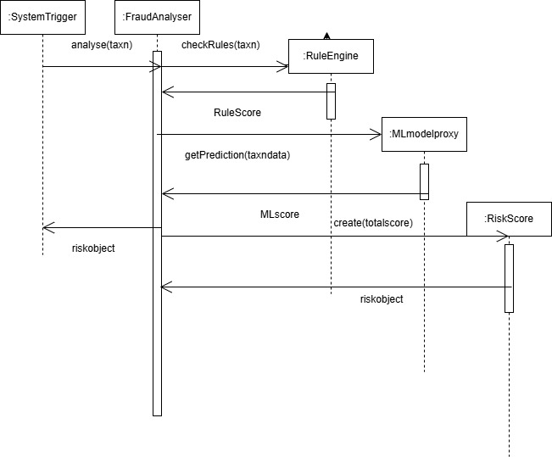

Collaboration Diagrams
Collaboration Diagram:1
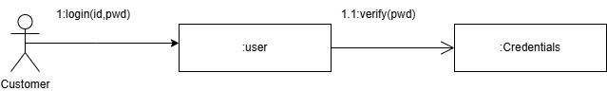
Collaboration Diagram:2
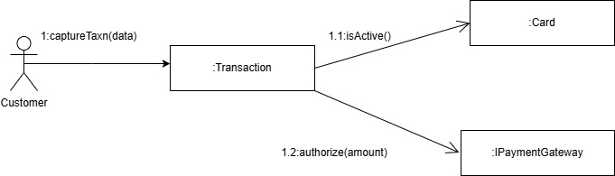

Collaboration Diagram:3
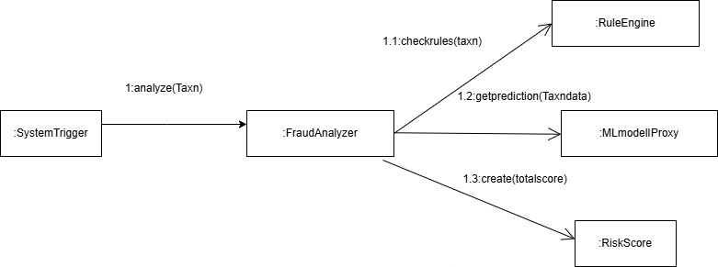

3.2 ER Diagrams
Key Entities and Relationships:
- User & Card: The USER entity represents all individuals interacting with the system, including customers and administrators. A one-to-many relationship exists here, as a single user can own multiple cards, but each card belongs to only one user.
- Transaction Flow:The core of the system is the transaction entity. It acts as the central link, connecting the card that initiated the purchase to the merchant who processed it. This is a one-to-many relationship in both directions, one card can initiate many transactions, and one merchant can process many transactions.
- Fraud Detection Logic: Every transaction automatically triggers a fraud analysis. This is a strict one-to-one relationship, meaning every single purchase is individually analysed. The analysis process EVALUATES the transaction against various FRAUD_RULES (like location checks or spending limits) to calculate a risk score.
- Alerting System: If the analysis detects high risk, it generates an alert. A single analysis can create multiple alerts. These alerts are then sent to the users to notify them of suspicious activity.
Reporting: Finally, the user (specifically those with an Admin role) veiws comprehensive reports thatsummarize fraud activities and system performance.

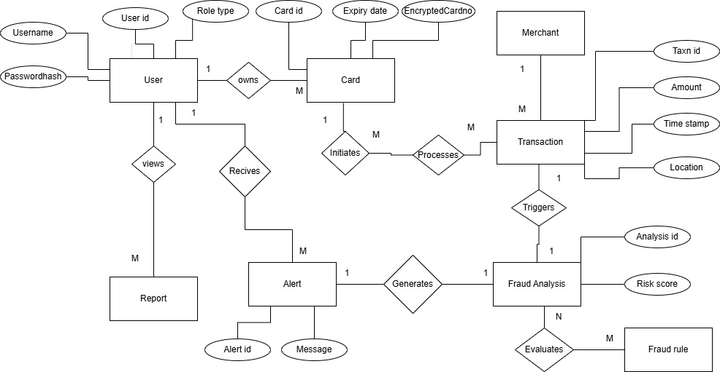

3.3 DFD Diagrams
Process Breakdown:
- 1.0 User & Security Management: The process begins here when a Customer or Admin logs in. This module takes their credentials and verifies them against the User Database (D1). It ensures that only authorized users can access the system and manages their security roles.
- 2.0 Transaction Processing: When a Merchant captures a sale, the transaction details (amount, time, location) flow into this module. It first communicates with the external Payment Gateway to authorize the funds. Simultaneously, it acts as a logger, saving a permanent record of the purchase into the Transaction Database (D2) for future reference.
- 3.0 Fraud Detection & Analysis: This is the "brain" of the system. It receives the live transaction data from Module 2.0. To make an accurate decision, it pulls historical data and patterns from the Fraud Rules/Patterns DB (D3). It combines this history with predefined rules to calculate a specific risk score for the transaction.
- 4.0 Alert & Control Reporting: Based on the risk score generated in the previous step, this module takes action. If a transaction is fraudulent, it sends a "Block Command" back to the processing module. It also sends an immediate SMS/Email Alert to the Customer. Finally, it generates a Fraud Report for the Admin and updates the Fraud Rules/Patterns DB (D3) with this new incident, helping the system learn and improve its future detection accuracy.

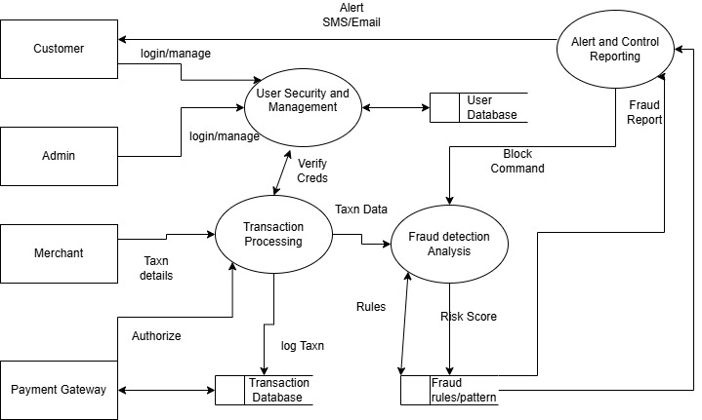

4. EXTERNAL INTERFACE REQUIREMENTS

4.1 User Interfaces
The system shall provide specific interfaces for each user class to interact efficiently with the fraud detection modules.
- Customer Interface:
  - Login Screen: Allows customers to securely access their account using a User ID and Password.
  - Notification Dashboard: Displays real-time alerts for suspicious transactions and provides options to verify or deny activity via OTP or confirmation buttons.
- Administrator Interface:
  - User Management Screen: Enables the admin to manage user roles, assign permissions, and oversee security settings.
  - Reporting Dashboard: Provides comprehensive views of fraud trends, system performance, and daily summary reports.
  - System Configuration: Allows for the update of detection rules and system parameters.
- Fraud Analyst Interface:
  - Investigation Console: A specialized view to list flagged suspicious transactions with detailed risk scores.
  - Action Panel: Provides controls to update the status of a case and contact customers for verification.
4.2 Hardware Interfaces
The system interacts with specific hardware components to ensure performance and data processing capabilities.
- Server Hardware: The application runs on high-performance servers requiring high RAM and fast processors to process millions of transactions simultaneously.
- Storage Devices: Large-capacity hard drives are utilized to store extensive logs of past transactions and historical user data.
- Network Hardware: The system depends on standard network interface cards (NICs) to maintain a continuous 24/7 high-speed internet connection for real-time detection.
4.3 Software Interfaces
The fraud detection system relies on external software components and services to function.
- Operating System: The server environment is designed to run on a secure Operating System, specifically Linux.
- Database Management System: A fast, relational database (SQL) is used to store and quickly retrieve user history and transaction logs.
- Payment Gateway: An external interface (IPaymentGateway) is used to communicate with banking networks (like Visa or PayPal) to authorize transaction amounts.
- Machine Learning Engine: An external AI system is integrated to calculate risk scores based on transaction patterns.
- Web Browsers: The analyst and admin dashboards are compatible with major web browsers such as Chrome, Edge, Firefox, and Brave.
4.4 Communication Interfaces
The system utilizes standard communication protocols to exchange data.
- Network Protocols: The system requires a continuous Internet connection using standard HTTP/HTTPS protocols for secure web access.
- Messaging Services: Interfaces with external SMS and Email servers to send real-time alerts and One-Time Passwords (OTPs) to customers.

5. OTHER NON-FUNCTIONAL REQUIREMENTS

5.1 Performance Requirements
- Real-Time Processing: The system must be capable of handling millions of transactions concurrently without significant latency.
- Database Efficiency: The database must be expandable to handle rapidly growing transaction history without slowing down the processing of new transactions.
- Availability: The system requires 24/7 uptime to ensure no fraudulent transaction goes unchecked.
5.2 Safety Requirements
- Data Integrity: The system must ensure that transaction logs and user history are stored accurately and are not corrupted during high-volume processing.
- Failover Mechanisms: In the event of a network failure, the system should have protocols to queue transactions or switch to backup connections to maintain monitoring capabilities.
5.3 Security Requirements
- Data Encryption: All stored data, especially sensitive user profiles and transaction details, must be encrypted.
- Access Control: Staff members (Admins and Analysts) must access the system using two-step verification (Password + OTP).
- Privacy Compliance: Customer data must be kept private and shared only with authorized personnel, strictly following banking laws and data protection acts.
5.4 Software Quality Attributes
- Scalability: The system architecture is designed to support an increasing volume of transactions and larger databases as the bank's customer base grows.
- Maintainability: The modular design (separating Rules, ML, and Alerts) allows for easy updates to fraud detection logic without disrupting the entire system.
- Usability: The interfaces for Analysts and Admins are designed to be intuitive and accessible via standard web browsers.
5.5 Business Policies/Rules
- Regulatory Compliance: The system must strictly adhere to banking laws and financial data protection regulations.
- Transaction Monitoring: All transactions must be monitored in real-time, any transaction exceeding a specific risk score must be automatically blocked or flagged for review.
- Data Privacy: Customer personal information is strictly confidential and cannot be shared with unauthorized third parties.

6.TESTING
Sample Code:1
class Transaction:
def __init__(self, amount, location, user_id):
self.amount = amount
self.location = location
self.user_id = user_id

class RuleEngine:
def check_rules(self, transaction):
risk_score = 0
if transaction.amount > 10000:
risk_score += 50
if transaction.location not in ["IN", "US"]:
risk_score += 30
return risk_score

class MLModelProxy:
def get_prediction(self, transaction_data):
return 45

class RiskScore:
def __init__(self, score, reason):
self.score = score
self.reason = reason

class FraudAnalyzer:
def __init__(self):
self.rule_engine = RuleEngine()
self.ml_model = MLModelProxy()

def analyze(self, transaction):
rule_score = self.rule_engine.check_rules(transaction)
ml_score = self.ml_model.get_prediction(transaction.__dict__)

total_score = (rule_score * 0.4) + (ml_score * 0.6)

reason = "High Rule Score" if rule_score > 40 else "Standard ML Prediction"
return RiskScore(total_score, reason)

White Box Testing
1.Flow Graph
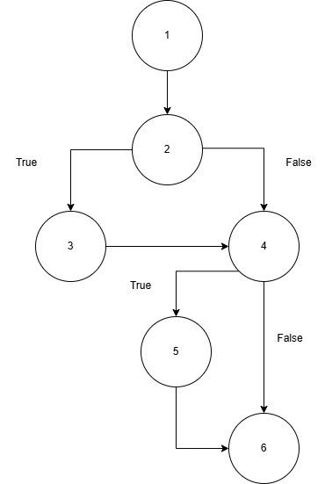
2.Cyclomatic Complexity
Using the predicate node formula:
V(G) = P + 1 V(G)= 2 + 1 = 3 We need to identify 3 independent paths.
The cyclomatic complexity is 3, requiring 3 independent paths to form the basis set:
- Path 1: 1, 2, 4, 6
- Path 2: 1, 2, 3, 4, 6
- Path 3: 1, 2, 4, 5, 6
3.Independent Program Paths
Path No | Independent Path (Node Sequence) | Test Input | Expected Output
P1 | 1, 2, 4, 6 | Transaction(5000, "IN") | 0
P2 | 1, 2, 3, 4, 6 | Transaction(15000, "US") | 50
P3 | 1, 2, 4, 5, 6 | Transaction(8000, "UK") | 30

import unittest

class Transaction:
def __init__(self, amount, location):
self.amount = amount
self.location = location

class RuleEngine:
def check_rules(self, transaction):
risk_score = 0
if transaction.amount > 10000:
risk_score += 50
if transaction.location not in ["IN", "US"]:
risk_score += 30
return risk_score

class TestRuleEngine(unittest.TestCase):
def setUp(self):
self.engine = RuleEngine()

def test_path_1(self):
self.assertEqual(self.engine.check_rules(Transaction(5000, "IN")), 0)

def test_path_2(self):
self.assertEqual(self.engine.check_rules(Transaction(15000, "US")), 50)

def test_path_3(self):
self.assertEqual(self.engine.check_rules(Transaction(8000, "UK")), 30)

if __name__ == '__main__':
unittest.main()
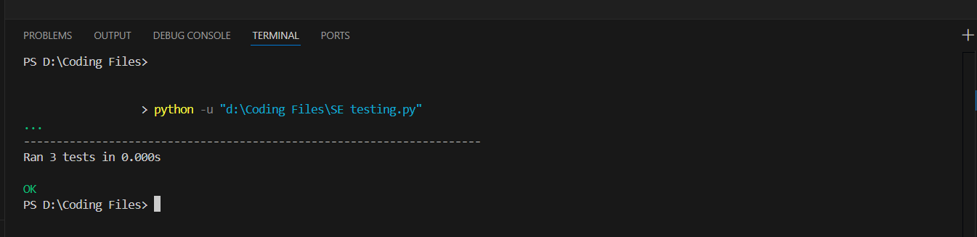

Black Box Testing
1.Fuctional Requirements
For check_rules() module:
- Base risk score must start at 0.
- If transaction amount > 10000 → add 50 to risk score.
- If transaction location is not "IN" or "US" → add 30 to risk score.
- Return the total calculated risk score.
2.Equivalence Partitioning
BB No | Test Input (Amount, Location) | Expected Output (Risk Score) | Classes Covered
BB1 | (5000, "IN") | 0 | EC2 (Valid Amount), EC4 (Valid Location)
BB2 | (15000, "US") | 50 | EC3 (High Amount), EC4 (Valid Location)
BB3 | (8000, "UK") | 30 | EC2 (Valid Amount), EC5 (Invalid Location)
BB4 | (20000, "FR") | 80 | EC3 (High Amount), EC5 (Invalid Location)
BB5 | (-500, "IN") | 0 | EC1 (Invalid Amount), EC4 (Valid Location)

3.Boundary Value Analysis
BB No | Test Input (Amount, Location) | Expected Output (Score) | Technique
BB1 | [9999, "IN"] | 0 | 10000 − 1
BB2 | [10000, "IN"] | 0 | 10000
BB3 | [10001, "IN"] | 50 | 10000 + 1
class Transaction:
def __init__(self, amount, location):
self.amount = amount
self.location = location

class RuleEngine:
def check_rules(self, transaction):
risk_score = 0
if transaction.amount > 10000:
risk_score += 50
if transaction.location not in ["IN", "US"]:
risk_score += 30
return risk_score

engine = RuleEngine()

print(engine.check_rules(Transaction(5000, "IN")))
print(engine.check_rules(Transaction(15000, "US")))
print(engine.check_rules(Transaction(8000, "UK")))
print(engine.check_rules(Transaction(20000, "FR")))
print(engine.check_rules(Transaction(-500, "IN")))

print(engine.check_rules(Transaction(9999, "IN")))
print(engine.check_rules(Transaction(10000, "IN")))
print(engine.check_rules(Transaction(10001, "IN")))

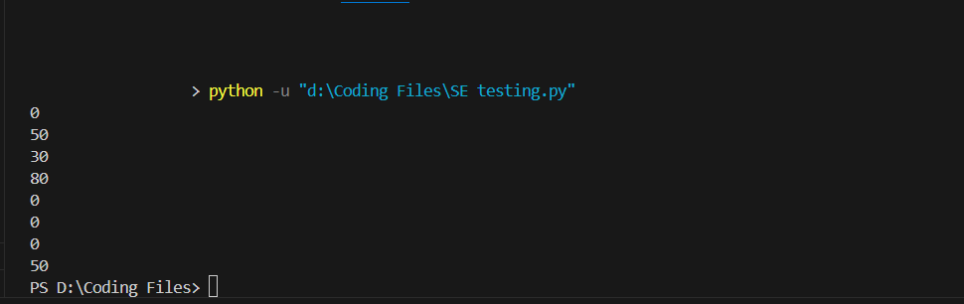

Sample Code:2
from datetime import datetime

class Card:
def __init__(self, card_number, expiry_date, is_locked=False):
self.card_number = card_number
self.expiry_date = expiry_date
self.is_locked = is_locked

def is_active(self):
return not self.is_locked and datetime.now().date() < self.expiry_date

class IPaymentGateway:
def authorize(self, amount):
raise NotImplementedError

class MockPaymentGateway(IPaymentGateway):
def authorize(self, amount):
if amount <= 50000:
return "AUTH_SUCCESS_789"
return "AUTH_FAILED_INSUFFICIENT_FUNDS"

class TransactionProcessor:
def __init__(self, gateway):
self.gateway = gateway

def process(self, card, amount):
if not card.is_active():
return "DECLINED_INACTIVE_CARD"

auth_code = self.gateway.authorize(amount)
return auth_code

White Box Testing
1.Flow Graph
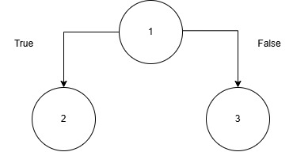
2.Cyclomatic Complexity
Using the predicate node formula: V(G) = P + 1 V(G) = 1 + 1 = 2
The cyclomatic complexity is 2, requiring 2 independent paths to form the basis set:
- Path 1: 1, 2
- Path 2: 1, 3
3.Independent Program Paths
Path No | Independent Path (Node Sequence) | Test Input | Expected Output
P1 | 1, 2 | card.is_active() == False, amount=1000 | "DECLINED_INACTIVE_CARD"
P2 | 1, 3 | card.is_active() == True, amount=1000 | "AUTH_SUCCESS_789"
import unittest
from datetime import datetime, timedelta

class Card:
def __init__(self, is_locked, expiry_date):
self.is_locked = is_locked
self.expiry_date = expiry_date

def is_active(self):
return not self.is_locked and datetime.now().date() < self.expiry_date

class MockPaymentGateway:
def authorize(self, amount):
return "AUTH_SUCCESS_789"

class TransactionProcessor:
def __init__(self, gateway):
self.gateway = gateway

def process(self, card, amount):
if not card.is_active():
return "DECLINED_INACTIVE_CARD"
auth_code = self.gateway.authorize(amount)
return auth_code

class TestTransactionProcessor(unittest.TestCase):
def setUp(self):
self.gateway = MockPaymentGateway()
self.processor = TransactionProcessor(self.gateway)
self.future_date = datetime.now().date() + timedelta(days=365)
self.past_date = datetime.now().date() - timedelta(days=10)

def test_path_1(self):
card = Card(is_locked=True, expiry_date=self.past_date)
self.assertEqual(self.processor.process(card, 1000), "DECLINED_INACTIVE_CARD")

def test_path_2(self):
card = Card(is_locked=False, expiry_date=self.future_date)
self.assertEqual(self.processor.process(card, 1000), "AUTH_SUCCESS_789")

if __name__ == '__main__':
unittest.main()

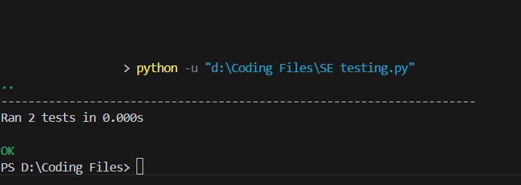

Black Box Testing
1.Functional Requirements
For process() module:
- Card status must be verified before processing.
- If card is inactive (locked or expired) → return "DECLINED_INACTIVE_CARD".
- If card is active → send amount to payment gateway for authorization.
- Return the authorization code from the gateway (e.g., "AUTH_SUCCESS_789").

2.Equivalence Partitioning
BB No | Test Input (Card Status, Amount) | Expected Output | Classes Covered
BB1 | Inactive Card, 1000 | "DECLINED_INACTIVE_CARD" | EC2 (Inactive Card), EC3 (Valid Amount)
BB2 | Active Card, 1000 | "AUTH_SUCCESS_789" | EC1 (Active Card), EC3 (Valid Amount)
BB3 | Active Card, 60000 | "AUTH_FAILED_INSUFFICIENT_FUNDS" | EC1 (Active Card), EC4 (High Amount)
BB4 | Inactive Card, 60000 | "DECLINED_INACTIVE_CARD" | EC2 (Inactive Card), EC4 (High Amount)
3.Boundary Value Analysis
BB No | Test Input (Card Status, Amount) | Expected Output | Technique
BB4 | [Active Card, 49999] | "AUTH_SUCCESS_789" | 50000 − 1
BB5 | [Active Card, 50000] | "AUTH_SUCCESS_789" | 50000
BB6 | [Active Card, 50001] | "AUTH_FAILED_INSUFFICIENT_FUNDS" | 50000 + 1

from datetime import datetime, timedelta

class Card:
def __init__(self, is_locked, expiry_date):
self.is_locked = is_locked
self.expiry_date = expiry_date

def is_active(self):
return not self.is_locked and datetime.now().date() < self.expiry_date

class MockPaymentGateway:
def authorize(self, amount):
if amount <= 50000:
return "AUTH_SUCCESS_789"
return "AUTH_FAILED_INSUFFICIENT_FUNDS"

class TransactionProcessor:
def __init__(self, gateway):
self.gateway = gateway

def process(self, card, amount):
if not card.is_active():
return "DECLINED_INACTIVE_CARD"
return self.gateway.authorize(amount)

gateway = MockPaymentGateway()
processor = TransactionProcessor(gateway)
future_date = datetime.now().date() + timedelta(days=365)
past_date = datetime.now().date() - timedelta(days=10)

print(processor.process(Card(True, past_date), 1000))
print(processor.process(Card(False, future_date), 1000))
print(processor.process(Card(False, future_date), 60000))
print(processor.process(Card(True, past_date), 60000))

print(processor.process(Card(False, future_date), 49999))
print(processor.process(Card(False, future_date), 50000))
print(processor.process(Card(False, future_date), 50001))

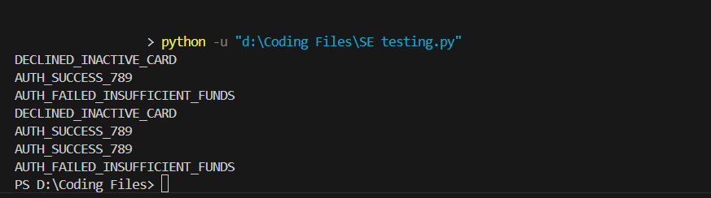

7. Conclusion
This Software Requirement Specification (SRS) document outlines the comprehensive architecture, design constraints, and operational guidelines for the Credit and Debit Card Fraud Detection System. By integrating real-time transaction monitoring , strict rule-based evaluations , and Machine Learning-based predictive analysis , the system is engineered to effectively identify and mitigate fraudulent financial activities before losses occur. The modular architectureencompassing User Management, Transaction Processing, Fraud Analysis, and Alert Reporting ensures high scalability, strict security compliance, and seamless integration with existing core banking networks.

DESIGN
ARCHITECTURE

Componet Level Diagram
- The Transaction Processor acts as the entry point, receiving payment data and routing it for authorization and security analysis.
- The composite Fraud Detection Engine evaluates this data by delegating tasks to its internal Rule and Machine Learning sub-components to generate a risk score.
- The Alert & Control Component uses this score to trigger external actions, such as blocking the transaction or sending SMS/email alerts to the customer.

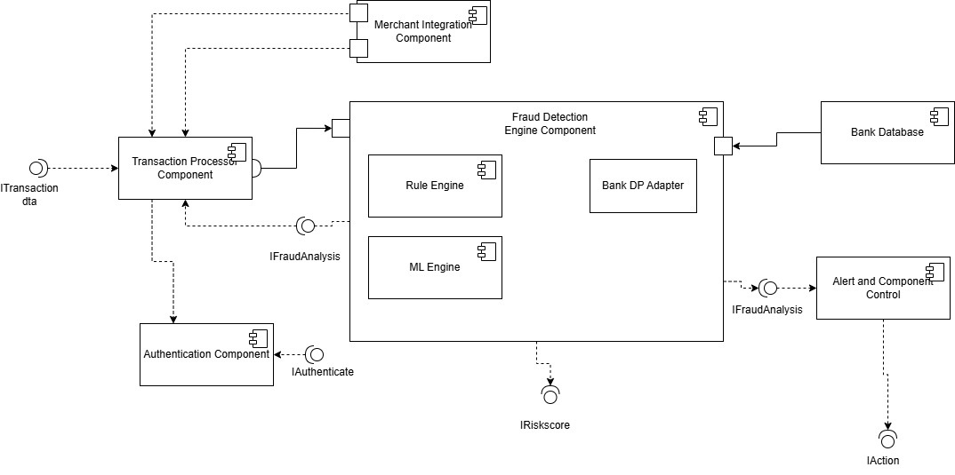
Deployment Level Diagram

- System Architecture Mapping: The diagram maps the software components of your fraud detection system to the physical hardware nodes where they will execute.
- Key Physical Nodes: It visually distributes the processing load across specific hardware environments , including the Merchant POS Terminal, Cloud Application Server Cluster, Dedicated ML Inference Server, and Central Database.
- Network Communication: Dotted lines illustrate the physical network communication paths required between your internal distributed servers and external entities like the Acme Bank Authorization Host.

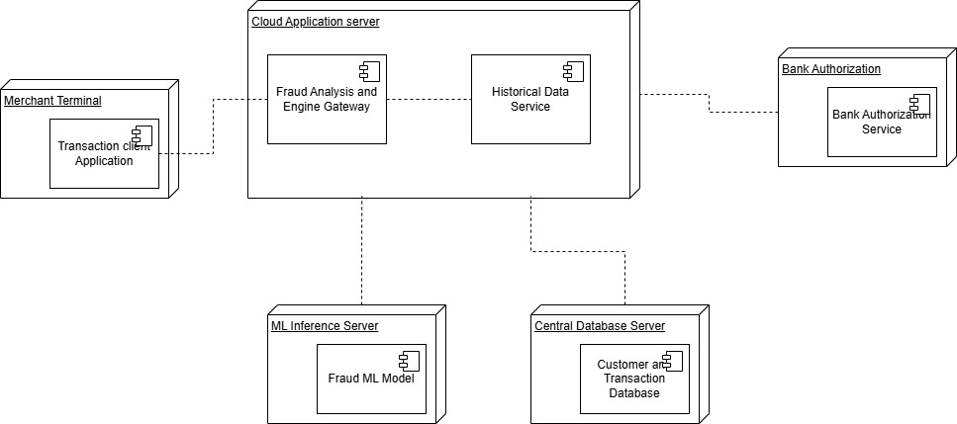

Product Metrics
Function Based Metrics
1. External Inputs (EIs): Data from a user or another application that provides distinct control information or updates internal files.
- Customer/Admin Login details.
- Captured transaction details from the Merchant.
- Updates to detection rules and system parameters by the Admin.
- Status updates for suspicious cases by the Fraud Analyst.
- Total EIs: 4
2.External Outputs (EOs): Information derived within the application and provided to the user.
- SMS and Email alerts sent to the Customer.
- Daily summary and fraud trend reports generated for the Admin.
- "Block Command" sent to the transaction processing module.
- Total EOs: 3
3. External Inquiries (EQs): Online inputs that result in immediate online outputs.
- Queries to view the list of flagged suspicious transactions in the Investigation Console.
- Queries to view real-time alerts on the Customer Notification Dashboard.
- Total EQs: 2
4. Internal Logical Files (ILFs): Logical groupings of data residing within the application's boundary.
- User Database storing credentials and roles.
- Transaction Database acting as a digital ledger.
- Fraud Rules/Patterns Database.
- Total ILFs: 3
5. External Interface Files (EIFs): Logical groupings of data residing external to the application but utilized by it.
- External Payment Gateway (IPaymentGateway) for authorization.
- External Machine Learning Engine for AI predictions.
- External Bank Database for checking account balances and customer history.
- Total EIFs: 3
Calculate the Complexity Adjustment Factor (CAF)
The Value Adjustment Factors (VAF) adjust the functional size based on the system's complexity. We assess the 14 general system characteristics on a scale of 0 (No Influence) to 5 (Essential).
- Reliable backup and recovery: 5 (Essential for maintaining data integrity of financial transaction logs ).
- Specialized data communications: 5 (Essential for connecting to external payment gateways via standard network interfaces ).
- Distributed processing functions: 5 (Essential, as it uses Cloud Application Servers, an ML Inference Server, and Central Databases ).
- Performance critical: 5 (Essential, requiring real-time processing of millions of concurrent transactions without latency ).
- Existing, heavily utilized operational environment: 4 (Significant, as it is a component of a larger core banking system ).
- Online data entry: 4 (Significant, requiring continuous capture of incoming transaction details ).
- Multi-screen online data entry: 2 (Moderate ).
- ILFs updated online: 5 (Essential, transaction histories grow rapidly and require constant logging ).
- Complex inputs, outputs, files, or inquiries: 4 (Significant, utilizing ML patterns and algorithmic risk scores ).
- Complex internal processing: 5 (Essential, running parallel Rule-Based and ML-Based analysis concurrently ).
- Code designed to be reusable: 3 (Average, features a modular design separating Rules, ML, and Alerts ).
- Conversion and installation included in design: 2 (Moderate ).
- Multiple installations in different organizations: 2 (Moderate ).
- Facilitate change and ease of use: 3 (Average, analyst and admin dashboards are compatible with major web browsers ).
Sum of value Adjustment Factors(ΣFi)=54

CAF=0.65+(0.01*ΣFi)
= 0.65+(0.01*54)
= 1.19
CAF = 1.19
Unadjusted Function Point (UFP) Calculation
Information Domain Value | Count | Simple | Average | Complex | Total
External Inputs (EIs) | 4 | 2 x 3 = 6 | 1 x 4 = 4 | 1 x 6 = 6 | 16
External Outputs (EOs) | 3 | 2 x 4 = 8 | 1 x 5 = 5 | 0 x 7 = 0 | 13
External Inquiries (EQs) | 2 | 0 x 3 = 0 | 2 x 4 = 8 | 0 x 6 = 0 | 8
Internal Logical Files (ILFs) | 3 | 0 x 7 = 0 | 2 x 10 = 20 | 1 x 15 = 15 | 35
External Interface Files (EIFs) | 3 | 0 x 5 = 0 | 1 x 7 = 7 | 2 x 10 = 20 | 27
Count Total (UFP) | 15 |  |  |  | 99

Final Function Point (FP) Calculation
FP = UFP * CAF
= 99 * 1.19
= 117.81
Estimation Calculations
- Total Function Points (FP): 117.81
- Development Effort: Assuming 1 FP equals approximately 10 hours of development.
  - 117.81 * 10 = 1178.1 hours
- Estimated Project Cost: Assuming a developer cost of ₹1000 per hour.
  - 1178.1 * 1000 = RS.11,78,100

COCOMO Model

1.Basic COCOMO Model
Convertinf FP to LOC

Total LOC = 117.81*50
=5890.5
KLOC = 5.89

The Basic COCOMO model is used for quick and slightly rough calculations of software costs using predicted software size.

Formulas:
- Effort (E) = A * (KLOC)^B
- Time (T) = C * (Effort)^D
- Persons required = Effort / Time

Constants for Organic Mode:
- A = 2.4, B = 1.05, C = 2.5, D = 0.38

Calculations:

- Effort:
E = 2.4*(5.89)^1.09
=15.05 Person-Months

- Time :
2.5*(15.05)^0.38
=7.00 Months

- Persons Required:
Persons = Effort/Time
=15.05/7
=2.15~2 Persons

Intermediate COCOMO Model

The Intermediate model adds a set of 15 subjectively assessed cost drivers to estimate development effort more accurately.
Determining the Effort Adjustment Factor (EAF): The EAF is the product of these cost drivers. Given that your system is a highly secure, real-time banking application , we must adjust specific Cost Driver ratings from the standard table.

- Required software reliability: Very High (1.40) — The system protects financial transactions where failure leads to direct monetary loss.
- Size of the application database: Very High (1.16) — It must handle millions of transactions and store extensive logs.
- Complexity of the product: Very High (1.30) — It combines parallel rule-based checks and external Machine Learning AI engines.
- Run-time performance constraints: Very High (1.30) — Requires 24/7 high-speed processing with zero latency.
5. Memory constraints
6. Volatility of the virtual machine environment
7. Required turnabout time
8. Analyst capability
9. Software engineering capability
10. Applications experience
11. Virtual machine experience
12. Programming language experience
13. Use of software tools
14. Application of software engineering methods
15. Required development schedule

These other 11 drivers are considerd as nominal(1.0)

EAF Calculation:
EAF = Product of cost drivers
EAF = 1.40 * 1.16 * 1.30 * 1.30 * 1 = 2.74
Formulas & Constants for Intermediate Organic Mode:
- A = 3.2, B = 1.05, C = 2.5, D = 0.38
- Effort (E) = (A * (KLOC)^B) *EAF
- Time (T) = C * (Effort)^D
Calculations:
- Effort:
E = (3.2 * (5.89)^(1.05))* 2.74
=20.06 * 2.74 = 54.96 Person-Months

- Time :
T = 2.5 * (54.96)^(0.38)
= 11.50 Months

- Persons Required:
Persons = 54.96 / 11.50
= 4.78 ~ 5 Persons

